Directions for Assigning Evaluator to an Evaluation
From the Evaluation Tab in your MyStaff Folder click the box to the left of the names of the teachers you want to assign to a different evaluator.
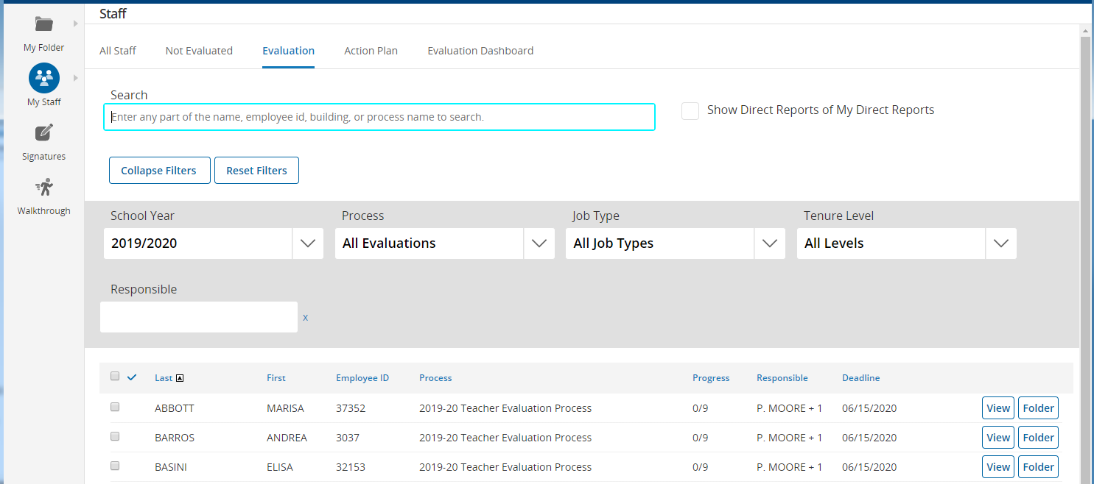

Scroll to the bottom of the page and under Bulk Actions select Assign Evaluator and click the GO button.
This will open a new window. Begin typing the last name of the evaluation you want to assign. When you see the name you want Click on the ASSIGN button to the right of the name.
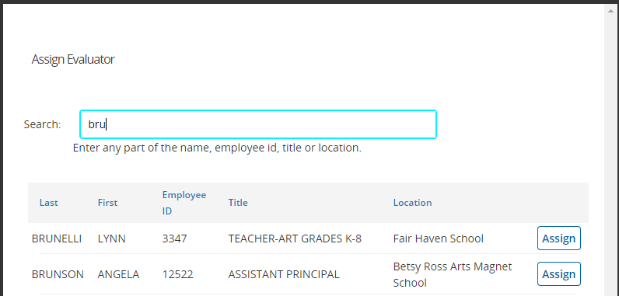
If you want to assign another evaluator make sure you clear the selection before selecting additional evaluations to assign or you will reassign the teachers you just assigned.

